Challenges and Opportunities In:
Robotics – Sensing and Power
  - This white paper explores the trends in the areas of sensing and power in robotics, current market needs and opportunities ahead.
Chetan Chavan
Krishna Nikhil Modali

Introduction
This paper highlights the opportunities and challenges in the robotics domain. Different types of robots, ranging from drones, arm based, underwater, soft robots, precision robots in medical units, humanoids, cobots etc., all have common challenges pertaining to enhancing their sensing and driving capabilities. Position, current in motors, tactile (on-off) are common sensing requirements whereas motor drivers for servo, BLDC, DC motors are the necessary hardware for actuation. As this industry is growing rapidly, we delve deeper into market insights and identify the scope for improving sensing and powering in robots.
Sensing is often characterized by precision, resolution, hysteresis, accuracy, bandwidth and most importantly the ability to diagnose itself in case of faults or probably do predictive diagnosis. Similarly, actuation in robots is mostly via different motors that need to be driven with sufficient power while managing overcurrent limits, thermal shutdown, torque and of course, fault diagnosis for minimizing down-time in bottleneck operations. Solutions that address these basic yet challenging requirements are the current need for robotics and most of industrial automation.

Contents
Introduction 2
Challenges and Opportunities 4
What is the benefit of using 48V in automotive? 4
The Advantages of 48V 5
Challenges With Voltages Higher Than 48V 5
48V Nominal Doesn’t Mean 48V Constant 6
Scope in Robotics for Sensing and Power 7
Key Benefits of Using the Allegro A89224 7
Allegro’s Advantage 8
Conclusion 9

Challenges and Opportunities

What is the benefit of using 48V in automotive?
The automotive industry is undergoing a significant transformation, driven by electrification and the increasing demand for advanced features. This evolution brings higher power requirements for various vehicle systems, including critical thermal management functions like electric pumps and cooling fans. Traditional 12V electrical systems are becoming increasingly challenged to efficiently and effectively power these higher loads. This is where the adoption of 48V systems offers a compelling solution.

Figure 1. Benefit of 48V systems in Automotive Applications
Relative benefit %
One of the primary drivers for moving to 48V is the fundamental relationship between power, voltage, and current (P=V×I). By increasing the system voltage from 12V to 48V, the current required to deliver the same amount of power is significantly reduced. For high-power loads like pumps and fans, this reduction in resistive losses is substantial, leading to improved overall system efficiency.
For high-power loads like pumps and fans, this reduction in resistive losses is substantial, leading to improved overall system efficiency.
This has several key advantages for thermal management systems. Lower current directly translates to reduced power losses in the wiring harness and electrical components, furthermore the motors weight could be also lighter if fully optimized on 48V. Recent studies demonstrate improved efficiency in mixed-signal environments.

Figure 2. Benefit of 48V systems in Automotive Applications
Caption Detail : Relative benefit %

The Advantages of 48V
The use of smaller cables and connectors also leads to higher power density, allowing for more compact system designs, which is increasingly important in space-constrained vehicle architectures. Beyond efficiency and packaging benefits, 48V systems enable the implementation of more powerful thermal management solutions. Higher voltage allows motors and pumps to operate at higher power levels, facilitating faster and more effective cooling. This is essential for managing the thermal loads generated by advanced powertrain components, battery packs, and other high-power electronics in modern vehicles.
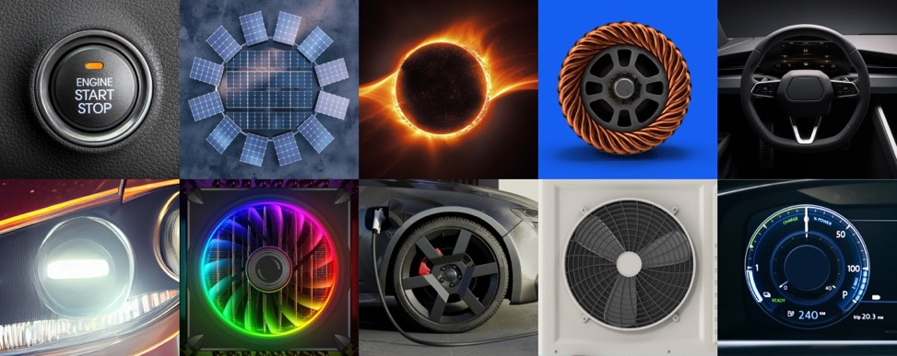
Figure 3: The Advantages of 48V
Furthermore, lower current allows for the use of smaller and lighter gauge wiring. This reduction in the size and weight of the wiring harness is a critical benefit in automotive design, contributing to overall vehicle weight reduction, which in turn improves fuel efficiency (for hybrids) or extends battery range (for EVs).
While increasing voltage introduces new design considerations, 48V strikes a balance by remaining below the 60V threshold for shock protection defined by international safety standards (like IEC61140, ISO6469, and ISO21780), making it a safer alternative compared to much higher voltage systems found in the main traction drives of EVs.

Challenges With Voltages Higher Than 48V
- Safety Regulations and Standards: Voltages above 60V DC referred to as Safe Extra Low Voltage (SELV) are considered dangerous to humans (IEC 60950, ISO6469, UL, NFPA, OSHA).
- Expensive Insulation and Isolation: Systems over 60V require robust insulation and isolation to protect humans and comes with higher cost and complexity.
- Component Availability: Components rated for higher voltage are less common and expensive.
There are other concerns like the need for thermal management, EMI/EMC interference, and energy efficiency at voltages higher than 48V. At the same time, there are also guidelines to keep in mind when designing for 48V systems—for example, spacing terminals in connectors to prevent arcing and taking precautions to avoid unwanted current flow from 48V to 12V.

48V Nominal Doesn’t Mean 48V Constant
For the 12V/24V system, there are well established standards (ISO16750, ISO7637) defining voltage transient profiles for the most severe conditions, such as load dump and transient voltages. For 48V systems, the current standards (ISO 21780 and Liefervorschriften [LV] 148) are specifically tailored for MHEVs, which require overvoltage points up to 70V. However, component ratings are much higher than 70V if switching transients or component margining are taken into account.
Figure 4. Top 3 Key Challenges
Challenge | Solution
Higher Voltage Buffer Requirements  48V systems demand components capable of withstanding higher voltage transients. Traditional ECUs designed for lower voltage systems may not provide sufficient headroom, potentially leading to component stress and failure. | The A89224 automotive MCU integrates a 90V MOSFET driver, leveraging Allegro’s 110V wafer technology. This provides a significant voltage buffer, offering engineers greater design margin.
Platform and Mini-Size Constraints  Automotive ECUs must be compact and adaptable to various vehicle platforms. Each platform may have unique form factor requirements, necessitating flexible hardware and software solutions. | The A89224 tackles these challenges through its high level of integration and ample memory capacity. By combining a powerful ARM Cortex-M4 core, a 90V MOSFET driver, and essential peripherals into a single chip, the A89224 enables compact ECU designs.
Robustness and Boundary Conditions  Battery cooling systems must operate reliably under harsh conditions, including extreme temperatures, vibrations, and potential airflow blockages. | The A89224 incorporates accurate ADC channels that enable precise sensing of load changes and system parameters. This allows the ECU to detect airflow blockages or other anomalies and adjust blower operation accordingly.
See the datasheet. 

Scope in Robotics for Sensing and Power
The programmability of the ARM Cortex-M4 core further enhances flexibility. Designers can configure various parameters, such as PWM frequency, dead time, and current limits, to optimize performance for specific motor and load conditions. This programmability enables designers to fine-tune the A89224 for a wide range of different applications like pumps or fans in variant vehicles.
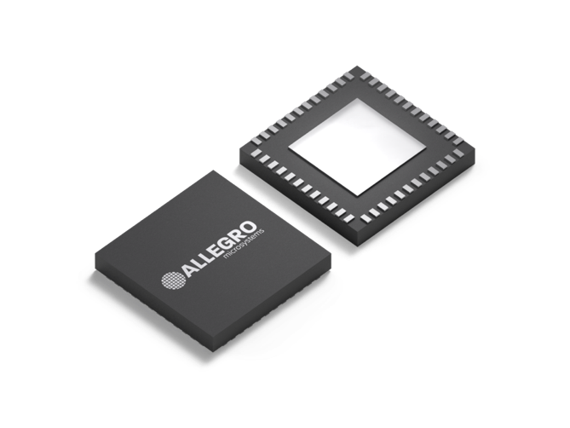
A89224’s core enables the implementation of sophisticated motor control algorithms, such as Field-Oriented Control (FOC), which optimize motor efficiency and performance. This allows the ECU to deliver more power with less energy consumption. The fast capture and conversion time allow maximum time for a motor control algorithm to calculate the FOC algorithm before the PWM duty cycle.
The A89224 supports both sensored and sensorless motor control, enabling advanced FOC and HFI.
Figure 5. The A89224 family of devices is a 48V-capable, automotive 3-phase BLDC driver with an integrated Arm M4 Cortex with up to 256kB of flash.
Ideal for sensorless FOC control of 3-phase BLDC and PMSM motor control applications, such as automotive fans and pumps
HFI for sensorless operation removes external sensors, reducing system complexity and BOM cost, and provides reliable torque at zero speed. This allows for more precise control and improved starting torque, crucial for demanding applications. Additionally, it is possible to reach noise reduction related to system operation with spectral signals related to the intrinsic motor functionality in high-frequency-injection. The proprietary Allegro Microsystems Motor Control Library is an example of this, being able, with a single shunt current sensor, to employ a high-frequency-injection based control method for low-speeds and high torques demands. This provides a significant noise reduction, due to multitone injection against an industrial standard of monotone injection (up to 25% noise reduction).

Key Benefits of Using the Allegro A89224
- Wide Operating Voltage Range (5.5V to 90V): Broad supply voltage range, extending up to 90V, provides significant margin for the 48V nominal voltage and allows it to withstand voltage transients that can occur in automotive electrical systems. This robustness against transients is crucial for reliable operation in the harsh automotive environment and directly addresses one of the key design challenges you mentioned.
- Powerful ARM coretex-M4 core + Large Memory (~256K Speed Flash + 32K DRAM): Combines a 32-bit ARM Cortex-M4 CPU core with an integrated three-phase gate driver. In addition, the flash reading speed is so quick that the CPU-core does not need to wait for a state for sequential operation codes. This high level of integration reduces the need for external components, leading to a more compact and potentially lower-cost solution, which aligns with the need for higher power density in 48V systems. The integrated MCU provides the processing power to run complex motor control algorithms like sensorless Field- Oriented Control (FOC) for efficient and precise control of pumps and fans.

Allegro’s Advantage
Efficient thermal management is paramount for the performance, longevity, and safety of 48V battery systems in modern vehicles. Allegro MicroSystems offers a comprehensive suite of innovative solutions that address the unique challenges of designing robust and reliable battery cooling systems. The A89224 automotive MCU, combined with Allegro’s high-accuracy current sensors, isolated gate drivers, PMICs, and motor drivers, empowers automotive engineers to create advanced thermal management systems that maximize battery life, improve vehicle performance, and enhance overall system reliability.

Conclusion
Efficient thermal management is paramount for the performance, longevity, and safety of 48V battery systems in modern vehicles. Allegro MicroSystems offers a comprehensive suite of innovative solutions that address the unique challenges of designing robust and reliable battery cooling systems. The A89224 automotive MCU, combined with Allegro’s high-accuracy current sensors, isolated gate drivers, PMICs, and motor drivers, empowers automotive engineers to create advanced thermal management systems that maximize battery life, improve vehicle performance, and enhance overall system reliability.

A. M. Keller and R. S. Huang, Advances in Wide-Bandgap Power Switching for Automotive Applications. Allegro Microsystems Whitepaper, Worcester, MA, USA, 2024.

